9/8/2009

親愛的家長:

一轉眼暑假就已過去, 希望大家都渡過了一個充實的夏天, 並且準備好迎接另一個新學期的開始。

今年密西根中文學校將於九月十二日開學, 新的地址如附圖. 我們於1:30-3:30 上課。請各位家長在開學當天, 陪同貴子女進入教室, 各班老師將簡短的與家長溝通並選出家長代表。第一週沒有課外活動, 但請至家長休息室報名課外活動。課外活動將於第二週(九月十九日)開始上課, 上課時間依舊為 3:30-4:30。

2009-2010 學年度計畫開十二班 (新增小小班), 全年上課32 週 。將舉辦的活動與往年也將大致相同, 以下是今年的班級, 老師及教室表:

年級 | 老師 | 教室
小小班 | 劉秀玲 | 2415
幼稚園班 | 陳美潔 | 2417
一年級班 | 吳宣萱 | 2419
二年級班 | 洪文君 | 2413
三年級班 | 陳康妮 | 2411
四年級班 | 黃琇雯 | 2409
七年級班 | 左永青 | 2407
八年級班 | 楊維琍 | 2405
高年級班 | 李偉玲 | 2442
馬立平九班 | 李君梅 | 2403
馬立平十一班 | 傅蓓蒂 | 2444
會話班(CSL) | 尹新妹 | 2421
家長休息室 |  | 2423/25

今後, 學校與家長之間的溝通將以電子郵件 (e-mail) 為主, 請各位家長務必留下正確的郵件地址。我們學校的郵件地址為:

Michigan_chinese_school@yahoo.com,

歡迎家長與學校聯絡, 並提供改進的意見。敬祝

學安

唐宗堯敬上
密西根中文學校校長
9/8/2009

Dear Parents:

Welcome to another new school year with Michigan Chinese School. I hope you have had a good summer and are ready to send the children back to school. This letter is to outline some important information for you:

- School will start on 9/12/2009. Map and directions to Madonna University and classrooms are attached. Classes will start at 1:30 and end at 3:30. Please accompany your child/ren to classroom on the first day as the teacher will briefly communicate their expectation with the parents and the class will elect a classroom representative.
- The extra-curriculum activity classes will start on the second week (9/19/2009). Please come to the Parent lounge on 9/12/2008 to register your child/ren for classes.
- MCS plans to have 12 classes this school year and will meet 32 times during the year. Most academic activities will be similar to last year. The following shows the grades and newly assigned classroom for year 2009-2010:

Grade | Teacher | Classroom
Pre-K | 劉秀玲 | 2415
Kindergarten | 陳美潔 | 2417
1st Grade | 吳宣萱 | 2419
2nd Grade | 洪文君 | 2413
3rd Grade | 陳康妮 | 2411
4th Grade | 黃琇雯 | 2409
7th Grade | 左永青 | 2407
8th Grade | 楊維琍 | 2405
Senior | 李偉玲 | 2442
Ma Liping V9 | 李君梅 | 2403
Ma Liping V11 | 傅蓓蒂 | 2444
CSL | 尹新妹 (Rose) | 2421
Parent Lounge |  | 2423/25

MCS is run by many volunteer parents of the school. Without their dedicated effort, the school will not be able to function. We welcome more parents to join our team to make our school the best it can be. In order to be more environmentally friendly, the school will mainly communicate through e-mails. Please make sure we have your correct e-mail address on record. Our school e-mail address is:
Michigan_chinese_school@yahoo.com

Please send your comments to us so we know how to improve our operation.

Best Regards,

Alex Tang
Principal, MCS

Madonna University
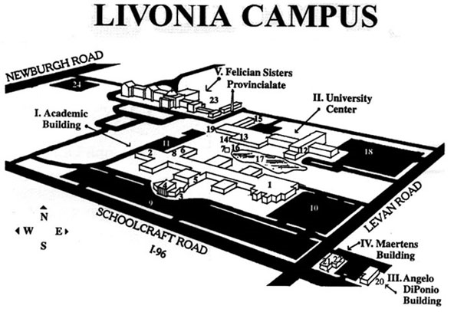
Michigan Chinese School is located at Academic Building 2nd floor. Classroom numbers range from 2403 to 2444. Please enter the building from the south side entrance shown above.

From the East: Take I-96 west. Exit at Levan Road (Exit 173B).
From the South: Take I-275 north to I-96 east. Exit at Newburgh/Levan Road (Exit 173). Drive east on the service drive (Schoolcraft). Turn left (north) at Levan.
From the West: Take I-96 east or take M-14 to I-96 east. Exit at Newburgh/Levan Road (Exit 173). Drive east on the service drive (Schoolcraft). Turn left (north) at Levan.

From the North: Take I-275 south to I-96 east. Exit at Newburgh/Levan Road (Exit 173). Drive east on service drive (Schoolcraft). Turn left (north) at Levan.

Academic Building Layout
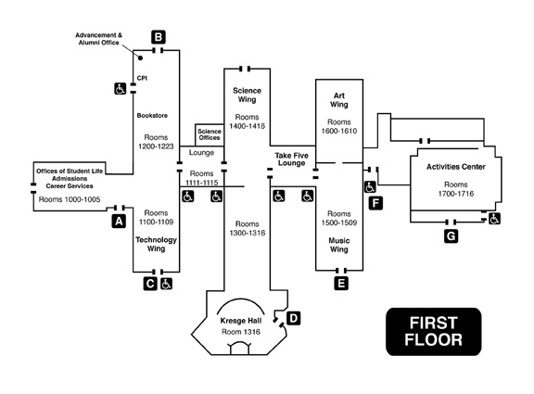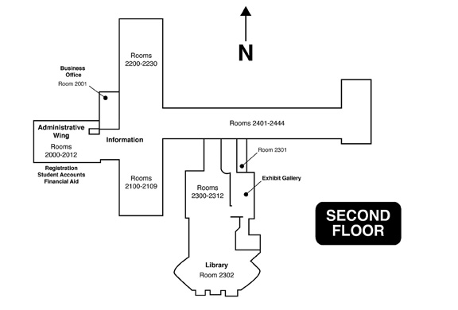

Michigan Chinese School Classroom Location

